**ACTIVATION FUNCTION**

Activation functions like a magic sauce for completion of complex tasks in deep learning

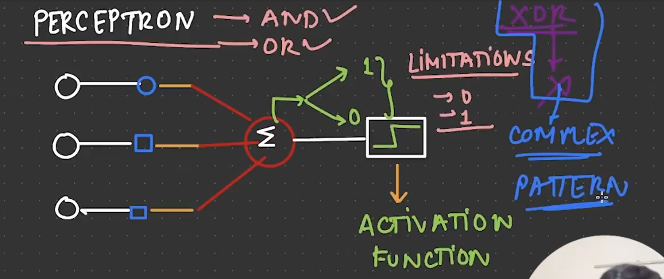

The perceptron function cannot evaluate the XOR function because of its complexity. This is where the activation functions come in place. The functions were not able to capture non-linear patterns. This is why activation functions are used to capture non-linear functions. There are several activation functions are available.

1. RELU (Rectified Linear Unit)
2. SIGMOID
3. LEAKY RELU
4. TanH (Hyperbolic Tangent)
5. SOFTMAX
6. Parametric RELU

These are the most used and main activation functions which are used in deep learning.

**SIGMOID**

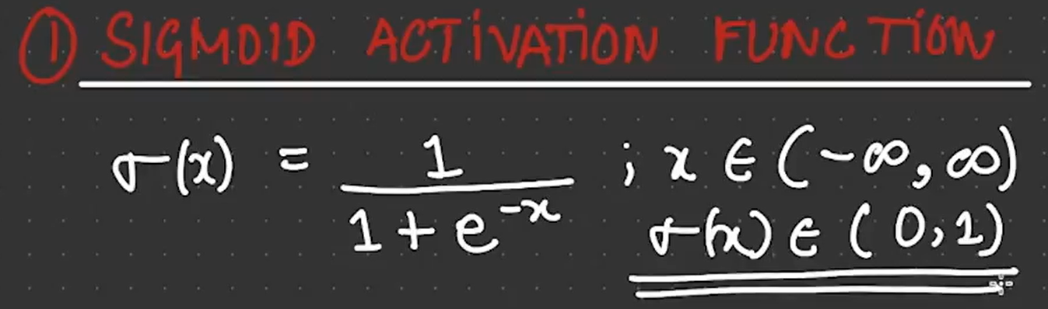

It gives output functions as 0 to 1.

We would need to understand the derivation of the activation functions because derivations help us to understand the Neural Network models to optimize for weight calculation of the neural networks.

**RELU**

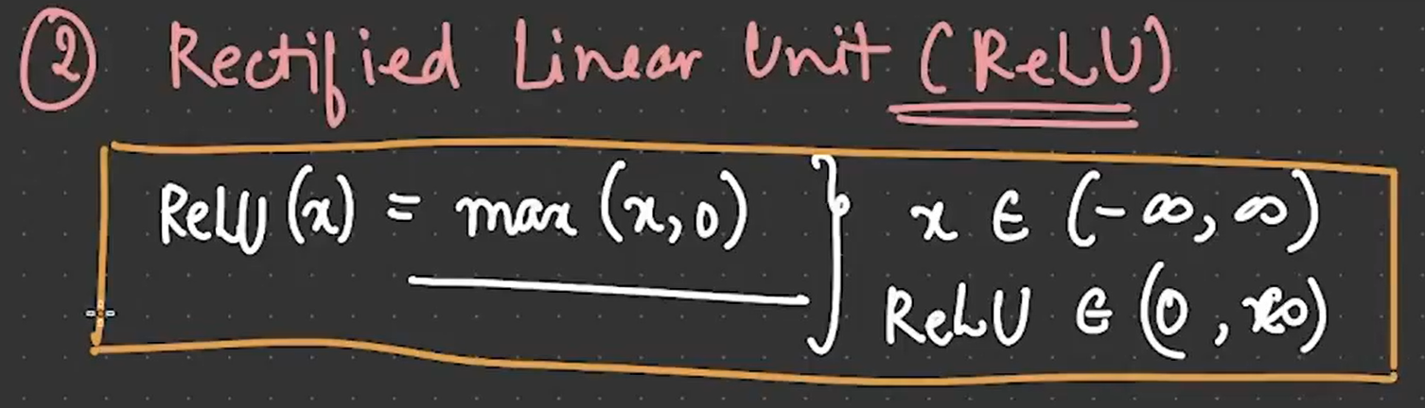

**Leaky RELU**

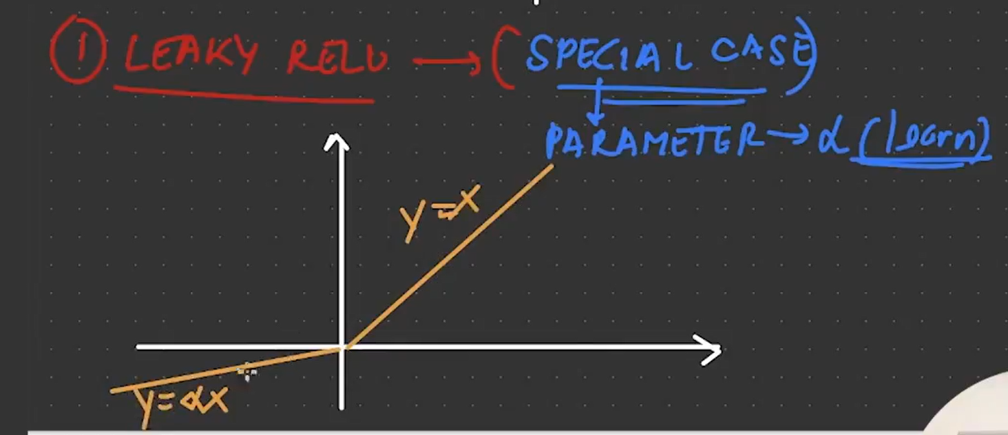

**SOFTMAX**

